**AWS Autoscaling Group (ASG)**

AWS Autoscaling Group allows us to launch multiple ec2 instances and maintain the count

ASG has two kinds of scaling

* + Fixed Number
  + Elasticity

Lets create an ec2 autoscaling group with fixed number of ec2 instances.

**Scenario:** create an ec2 autoscaling group with fixed number of ec2 instances with php info application.

Steps:

Ensure we have an ami with php info and stress tool installed.

Create a Launch Template with php info ami  
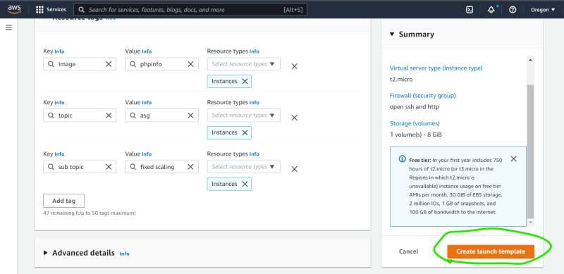

Create auto scaling group  
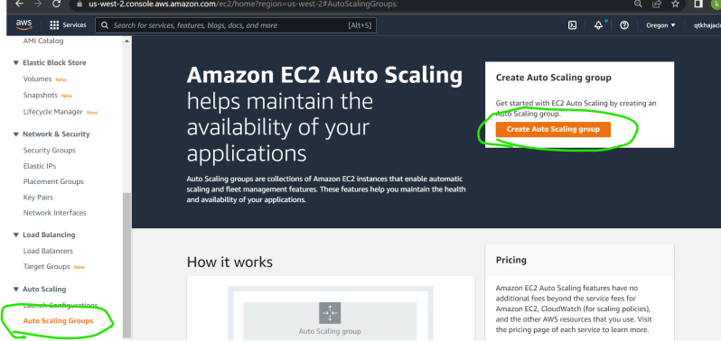  
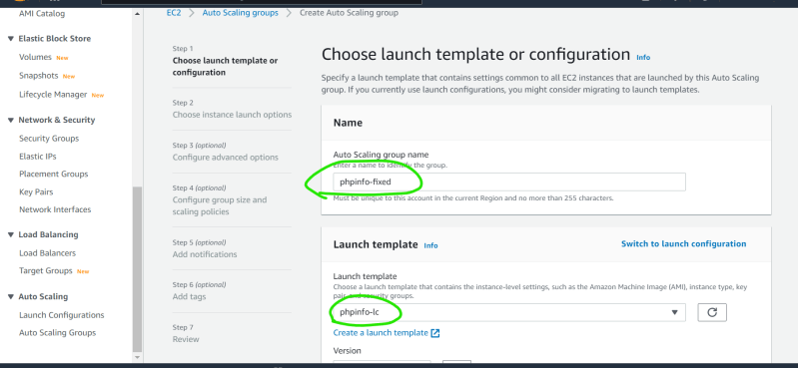  
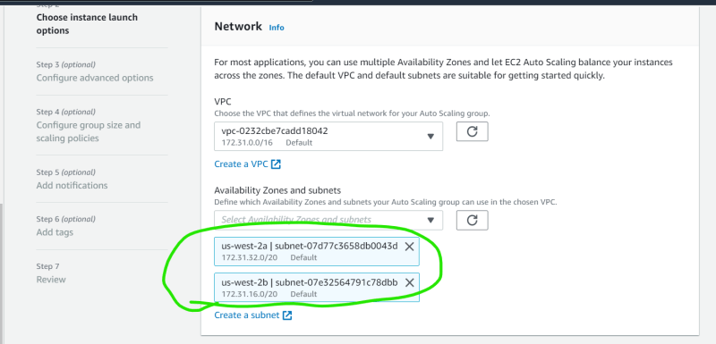  
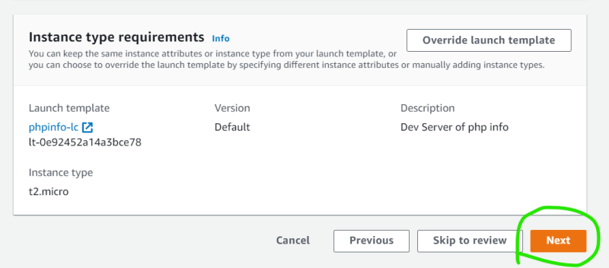  
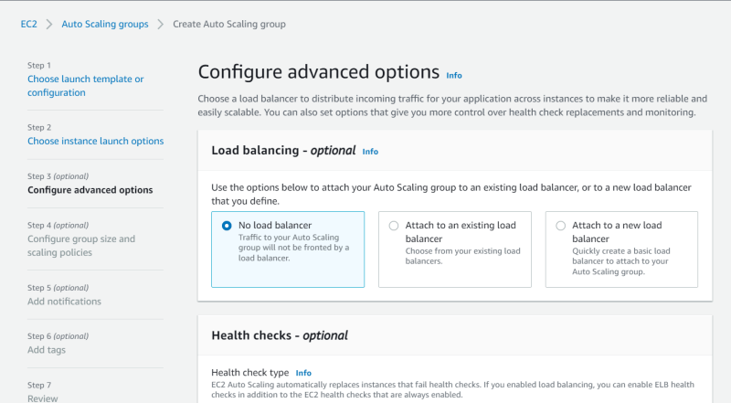  
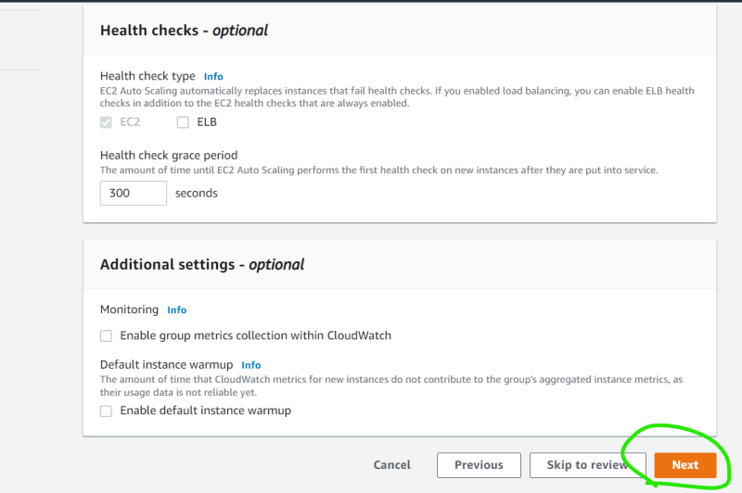  
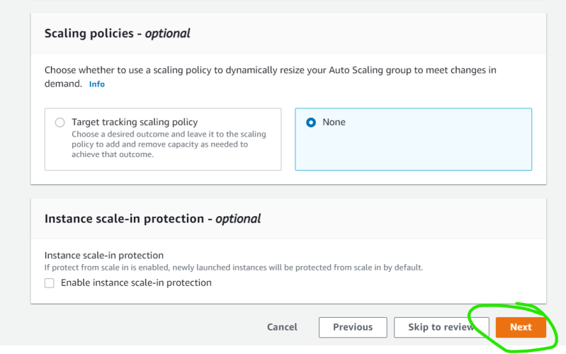  
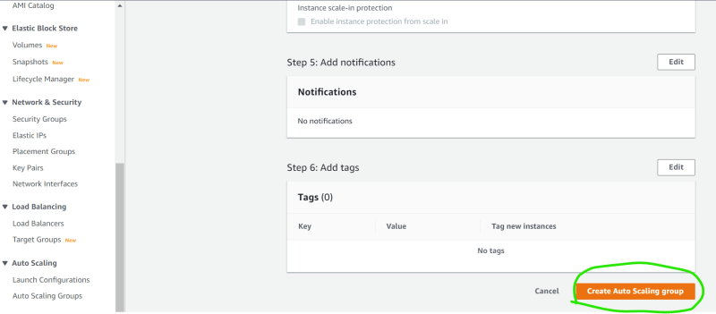  
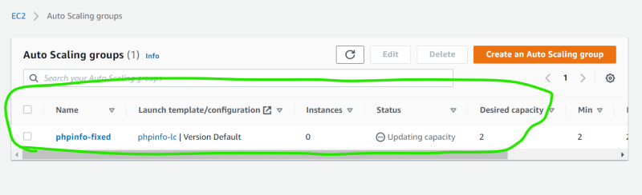  
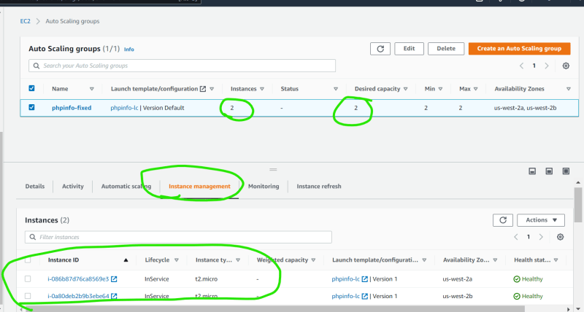  
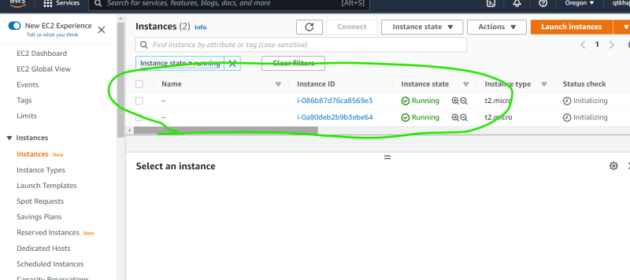

Right now two ec2 instances are running lets terminate one ec2 instance and see what happens  
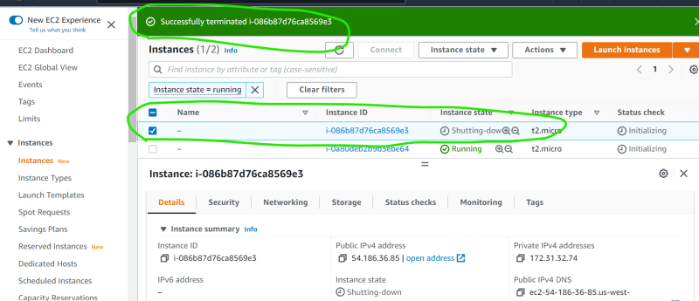  
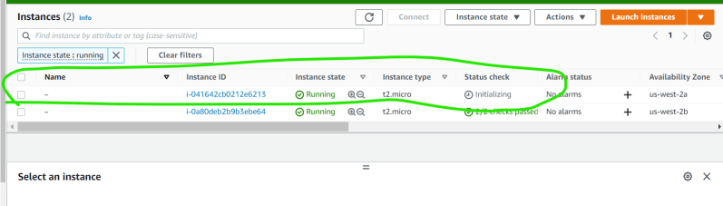

Once you are done either delete the autoscaling group or update the desired capacity to zero.  
